1. **Anagram Strings**

Given two strings **s1**and **s2**consisting of lowercase characters. The task is to check whether two given strings are an anagram of each other or not. An anagram of a string is another string that contains the same characters, only the order of characters can be different. For example, act and tac are an anagram of each other. Strings **s1**and **s2**can only contain lowercase alphabets.

Note: You can assume both the strings s1 & s2 are **non-empty**.

**Examples :**

**Input:** s1 = "geeks", s2 = "kseeg"

**Output:** true

**Explanation:** Both the string have same characters with same frequency. So, they are anagrams.

**Code:**

import java.util.*;

class Anagram{

public static boolean areAnagrams(String s1, String s2) {

HashMap<Character,Integer> hp=new HashMap<>();

for(char i:s1.toCharArray()){

hp.put(i,hp.getOrDefault(i,0)+1);

}

for(char i:s2.toCharArray()){

if(!hp.containsKey(i)) return false;

else{

hp.put(i,hp.get(i)-1);

}

if(hp.get(i)==0) hp.remove(i);

}

return hp.isEmpty();

}

public static void main(String[] args){

String s1 = "geeks";

String s2 = "kseeg";

System.out.println(areAnagrams(s1,s2));

}

}  
  
**Output**:

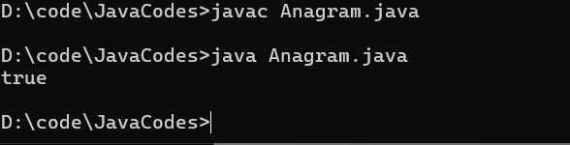

Time Complexity:O(n+m)

Space Complexity:O(k) (Note: k denotes no of unique characters)

**2.Row With Max 1’s**

You need to find and return the index of the first row that has the most number of 1s. If no such row exists, return -1.  
Note: 0-based indexing is followed.

Examples:

Input: arr[][] = [[0, 1, 1, 1],  
 [0, 0, 1, 1],  
 [1, 1, 1, 1],  
 [0, 0, 0, 0]]

Output: 2

Explanation: Row 2 contains 4 1's.

**Code:**

import java.util.*;

class rowMaxones{

public static int rowWithMax1s(int arr[][]) {

// code here

int row=arr.length;

int col=arr[0].length;

int ind=-1;

int l=0;

int r=col-1;

while(l<row && r>=0){

if(arr[l][r]==0){

l++;

}

else{

ind=l;

r--;

}

}

return ind;

}

public static void main(String[] ar){

int[][] arr = {{0, 1, 1, 1}, {0, 0, 1, 1},{1, 1, 1, 1},{0, 0, 0, 0}};

System.out.println(rowWithMax1s(arr));

}

}

**Output**:

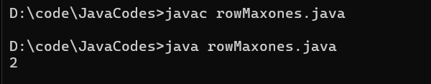

3. **Longest consequtive subsequence**

Given an array **arr** of non-negative integers. Find the **length** of the longest sub-sequence such that elements in the subsequence are consecutive integers, the**consecutive numbers** can be in **any order.**

**Examples:**

**Input:** arr[] = [2, 6, 1, 9, 4, 5, 3]

**Output:** 6

**Explanation:** The consecutive numbers here are 1, 2, 3, 4, 5, 6. These 6 numbers form the longest consecutive subsquence.

**Code:**

import java.util.*;

public class Longestsubsequence{

public static int findLongestConseqSubseq(int[] arr) {

// code here

int[] sub=new int[100000];

int max=Integer.MIN_VALUE;

int c=0;

for(int i:arr){

sub[i+1]++;

}

for(int i:sub){

if(i!=0){

c++;

max=Math.max(max,c);

}

else c=0;

}

return max;

}

public static void main(String[] ar){

int[] arr= {2, 6, 1, 9, 4, 5, 3};

System.out.println(findLongestConseqSubseq(arr));

}

}

**Output**:

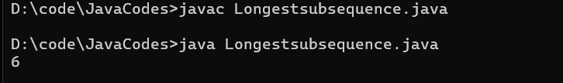

**Time Complexity:O(n)**

**Space Complexity:O(1)**

**PROBLEM 4 :**

**longest palindrome in a string**

**CODE :**

import java.util.*;

public class Main {

public static void main(String... argv) {

Scanner scan = new Scanner(System.in);

System.out.println("Enter the String :");

String s = scan.next();

int n = s.length();

int start = 0;

int maxLen = 1;

for(int i=0;i<n;i++){

int len1 = helper(s,i,i);

int len2 = helper(s,i,i+1);

int len = Math.max(len1,len2);

if(maxLen < len){

maxLen = len;

start = i - (len - 1)/2;

}

}

System.out.println ("Result is :" + s.substring(start,start + maxLen));

}

public static int helper(String s,int left,int right){

while(left>=0 && right<s.length() && s.charAt(left) == s.charAt(right)){

left--;

right++;

}

return right - left - 1;

}

}

**Output:**

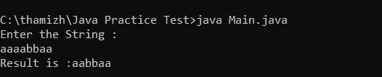

**5.** **rat in a maze problem**

**CODE :**

import java.util.*;

public class Main {

public static void main(String... argv) {

Scanner scan = new Scanner(System.in);

System.out.println("Enter the Number of rows :");

int n = scan.nextInt();

System.out.println("Enter the Number of Columns :");

int m1 = scan.nextInt();

int[][] m = new int[n][m1];

System.out.println("Enter the Elements in the matrix 0 or 1 :");

for(int i=0;i<n;i++){

for(int j=0;j<m1;j++){

m[i][j] = scan.nextInt();

}

}

ArrayList<String> result = new ArrayList<>();

boolean[][] board = new boolean[n][n];

if(m[0][0]==0){

result.add("-1");

System.out.println(result);

}else{

helper(0,0,m,board,n,"",result);

System.out.println(result);

}

}

public static void helper(int row,int col,int[][] m,boolean[][] board,int n,String s,ArrayList<String> result){

if(row<0 || row>=n || col<0 || col>=n || board[row][col] || m[row][col]!=1) return;

if(row==n-1 && col==n-1 && m[row][col]==1){

result.add(s);

return;

}

board[row][col] = true;

helper(row+1,col,m,board,n,s+"D",result);

helper(row-1,col,m,board,n,s+"U",result);

helper(row,col+1,m,board,n,s+"R",result);

helper(row,col-1,m,board,n,s+"L",result);

board[row][col] = false;

}

}

**Output:**

